Jayvhan Lawrence P. Babarin
Learning Outcome #4: Data Splitting
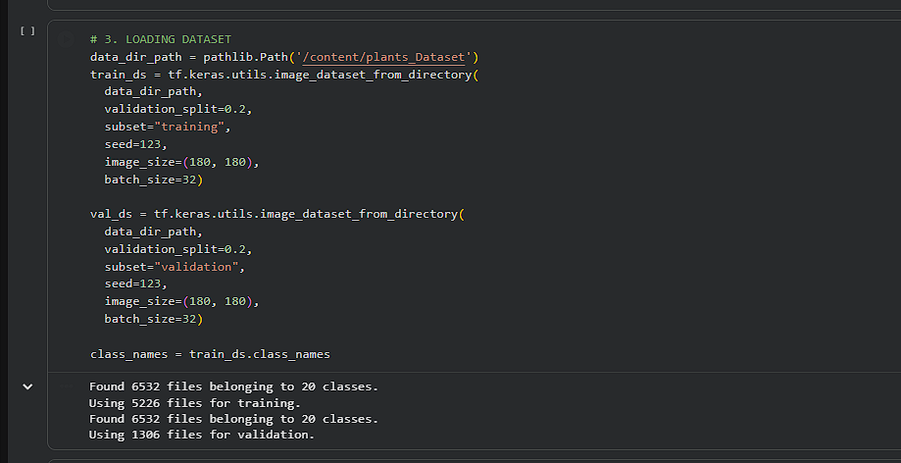

My explanation: for this lab i split the dataset into 80-20. 80% (5226 images) was for training the model so it can learn, and the other 20% (1306 images) was save as a validation set to test if the model actually works on new pictures it hasnt seen.
Student Reflection and Final Guide Questions
1. What signs indicated overfitting in your first model?
The training graphs showed I first observed training accuracy which reached almost 100% however validation accuracy remained at a lower value without any improvement. The two lines demonstrated a major gap which showed that the model had mastered the exact training pictures without developing the ability to identify objects through general understanding.
2. How did data augmentation affect validation accuracy?
Data augmentation made a huge difference. The validation accuracy improved while the training process became more consistent. The system required to operate without "cheating" through memorization since the system needed to learn genuine features which would bridge the existing gap between two earlier displayed graph elements.
3. What is the purpose of dropout layers?
Dropout layers basically tell the model to "turn off" some neurons at random while it's training. The network needs this method because it stops learning from particular pixels or patterns which represents the most effective method to avoid overfitting.
4. Why does data augmentation improve generalization?
The method creates multiple image copies that various viewers view as distinct pictures through its ability to flip images and rotate them and zoom in on them. The model learns that a plant maintains its identity as the same plant when viewed from different angles because this reflects actual visual perception in real life.
5. Compare accuracy before and after improvements.
The model showed high instability before I implemented changes because it displayed high training accuracy, which led to overfitting and resulted in poor validation performance. The accuracy curves became more uniform after I introduced Dropout and Data Augmentation, which resulted in the model becoming trustworthy for assessing unknown data.

6. Which technique contributed most to improvement?

Data Augmentation proved to be the most valuable asset for my work. It provided the model with diverse training materials because it delivered multiple new training data sets without requiring me to search for and upload thousands of new images.

7. Why is saving the model important?

We must save the model because it contains the "trained weights" which function as the "brain" for the AI system that we dedicated our efforts to train. This method enables us to load the file which we will use in applications without needing to spend time and computing resources to build it again from the beginning.

8. How can this model be deployed in a real-world system?

The model can be saved and integrated into applications such as mobile software. A user can take a plant photo using their smartphone, and the application will employ the trained model to immediately determine the plant species.

